**Example:** If my project were “Lack of single-dose vaccine for pathogens in developing countries”, then here are a couple example sources and annotations that I might make:

**Innovation/Approach**

1) Guarecuco, Rohiverth, et al. "Immunogenicity of pulsatile-release PLGA microspheres for single-injection vaccination." Vaccine (2017). https://www.sciencedirect.com/science/article/pii/S0264410X17307648

1. Describe in their report how to achieve multiple releases of vaccine with design of PLGA microparticles. They tuned polymer composition, molecular weight, and antigen loading to tune the release profile.
2. May be a good reference to support my idea about the plausibility of creating a single reagent that releases the vaccine at different time points and is able to elicit an effective immune response.

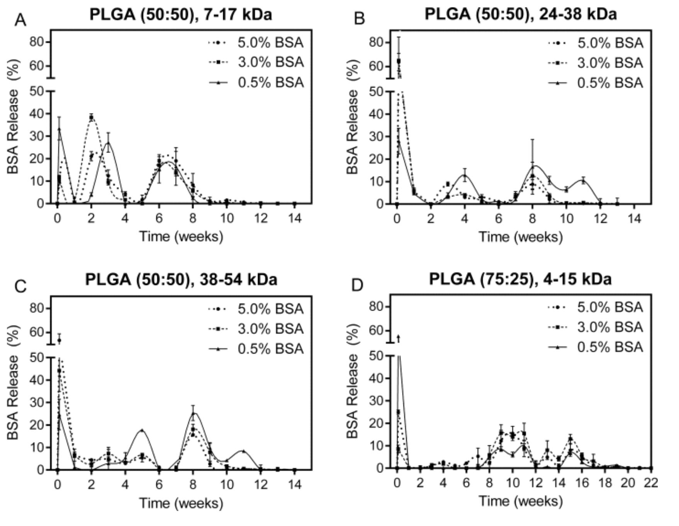

2) McHugh, Kevin J., et al. "Fabrication of fillable microparticles and other complex 3D microstructures." Science 357.6356 (2017): 1138-1142.

1. http://science.sciencemag.org/content/357/6356/1138/tab-figures-data
2. Describe top-down approach to synthesizing particles for cargo release. This enables high encapsulation efficiency since it is not just a bottom up approach.
3. This will be great supporting data for my idea of injecting microparticles with vaccine solution so that I get a high encapsulation efficiency, standardization of particles, control over release profiles, and decreasing the cost to manufacture Etc.

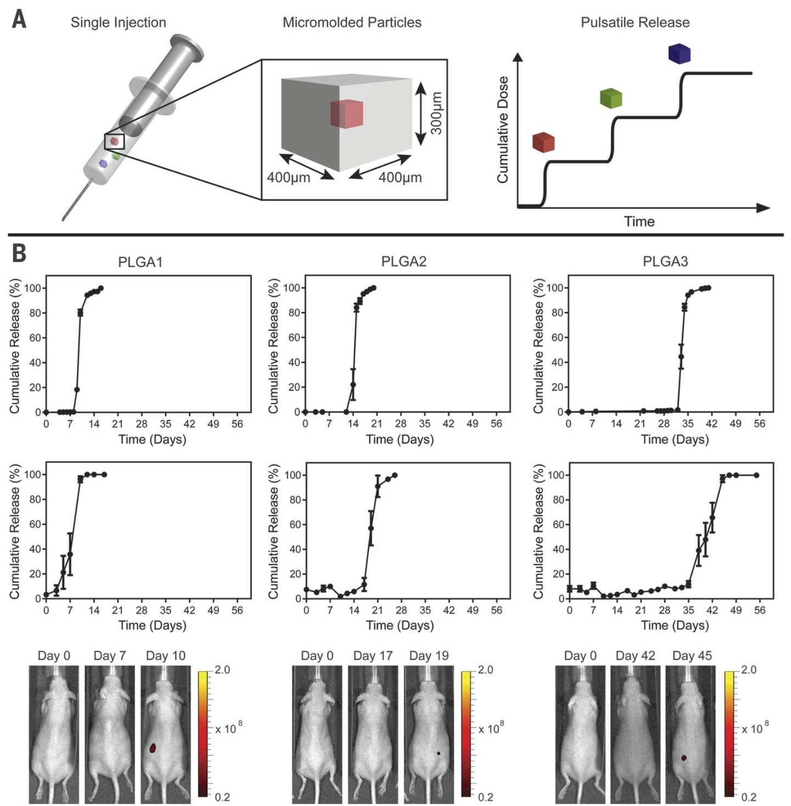

Or

